**Project Title:**

**"Tracking AI Tool Popularity Using SQL – AI Trends Tracker"**

**📌 Project Summary :**

Analyzed search trend data of **AI tools like ChatGPT, Midjourney, and Claude AI over 17 days using SQL**. Extracted valuable insights such as **the most popular tools, daily trends, spikes in traffic, and volatility. Used aggregate functions, filtering, and window functions** to derived 10 key business insights.

**🧠 Objective:**

To analyze how public interest in various AI tools changes over time and to identify which tools are gaining or losing popularity using basic SQL queries **(without joins)**.

**📂 Database Used:**

**Database Name:** projects  
**Table:** search_trends  
**Columns:**

* id (INT, Primary Key)
* search_date (DATE)
* tool_name (VARCHAR)
* search_volume (INT)

**Rows Inserted:** 51 (covering 3 AI tools over 17 days)

**🛠️ Skills Used:**

* SQL (Basic to Intermediate)
* Aggregations (SUM, AVG, MAX, MIN)
* GROUP BY, ORDER BY, WHERE, LIMIT
* Filtering and Ranking
* Window Functions

**🔍 Key Business Insights & SQL Queries:**

| **No.** | **Analysis Task** | **Insight** | **SQL Concept Used** |
| --- | --- | --- | --- |
| 1. | Most popular AI tool | **ChatGPT** has the highest total search (181,500) | SUM, GROUP BY |
| 2. | Daily average search per tool | ChatGPT ≈ **10,676/day** | AVG, ROUND |
| 3. | Search trend per day | Daily public interest is **increasing** | SUM, GROUP BY |
| 4. | Peak traffic day | Highest total traffic on **2025-06-17** (21,700) | MAX, LIMIT |
| 5. | Daily trend for ChatGPT | ChatGPT shows **steady growth** | WHERE, GROUP BY |
| 6. | Viral spikes (>11K/day) | Only ChatGPT crossed **11K+** on 6 occasions | WHERE >, ORDER BY |
| 7. | Most volatile tool | ChatGPT had the highest fluctuation (**+2200**) | MAX - MIN |
| 8. | Weekly trend (Week 1) | ChatGPT leads with **69,900** searches | BETWEEN, GROUP BY |
| 9. | Highest single-day search | ChatGPT – 11,800 on **2025-06-17** | ORDER BY, LIMIT |
| 10. | Tool popularity rank | 1. ChatGPT, 2. Midjourney, 3. Claude AI | RANK() OVER() |

**📉 Graph Suggestions (optional for Power BI/Excel):**

* 📈 Line graph: Daily trend per tool
* 📊 Bar chart: Total search per tool
* 🧯 Area chart: Weekly growth
* 🔼 Column chart: Volatility comparison

**SQL Mini Case Study – AI Trends Tracker**

• Built a mini-SQL project analyzing search trends of ChatGPT, Midjourney, and Claude AI.  
• Generated 10 key insights using aggregations, filtering, and ranking (no joins used).  
• Identified trend patterns, viral moments, and tool popularity growth over 17 days.  
• Tools Used: MySQL, Excel (optional), Data Analytics

**Screenshots:**

**Table Schema :**

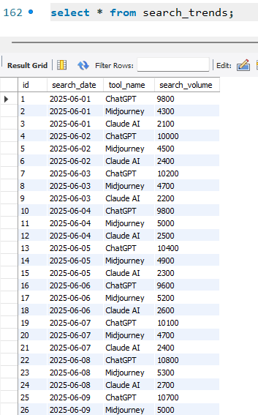

**Query 1 :**

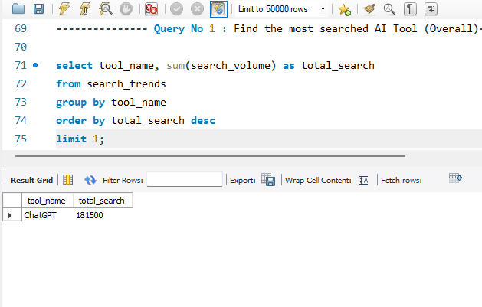

**Query 2 :**

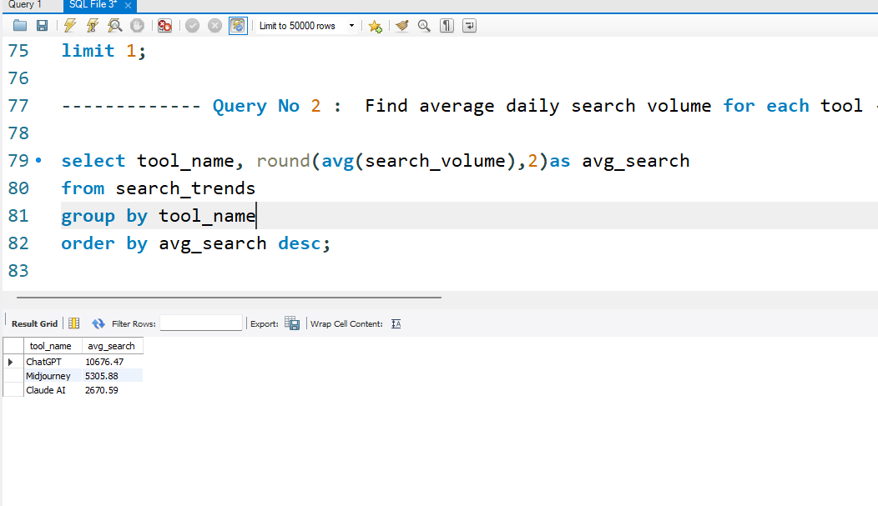

**Query 3 :**

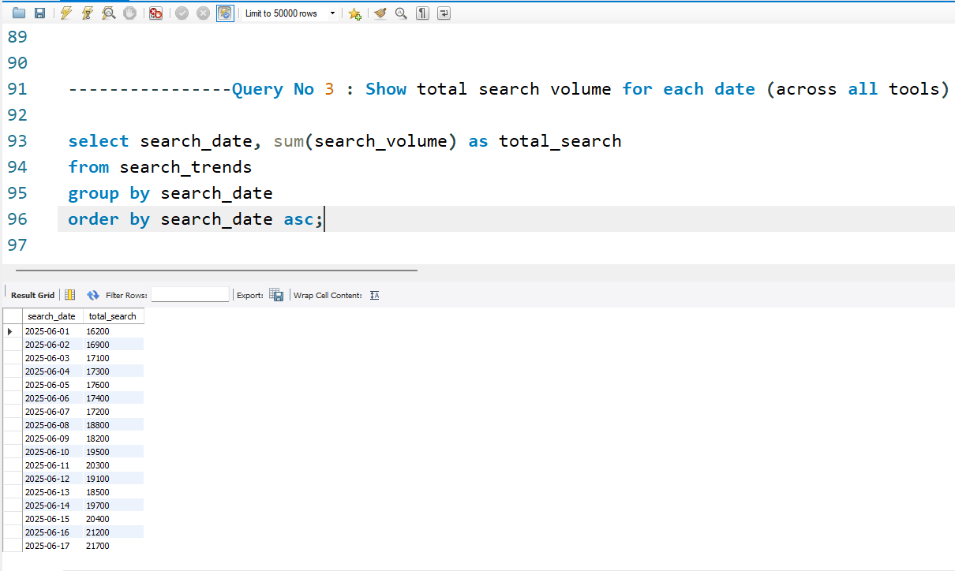

**Query 4 :**

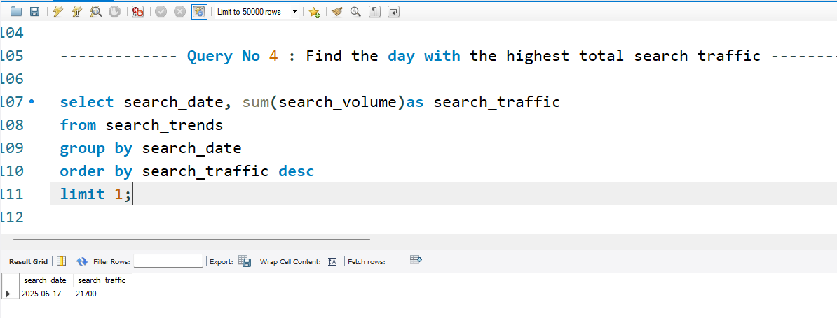

**Query 5 :**

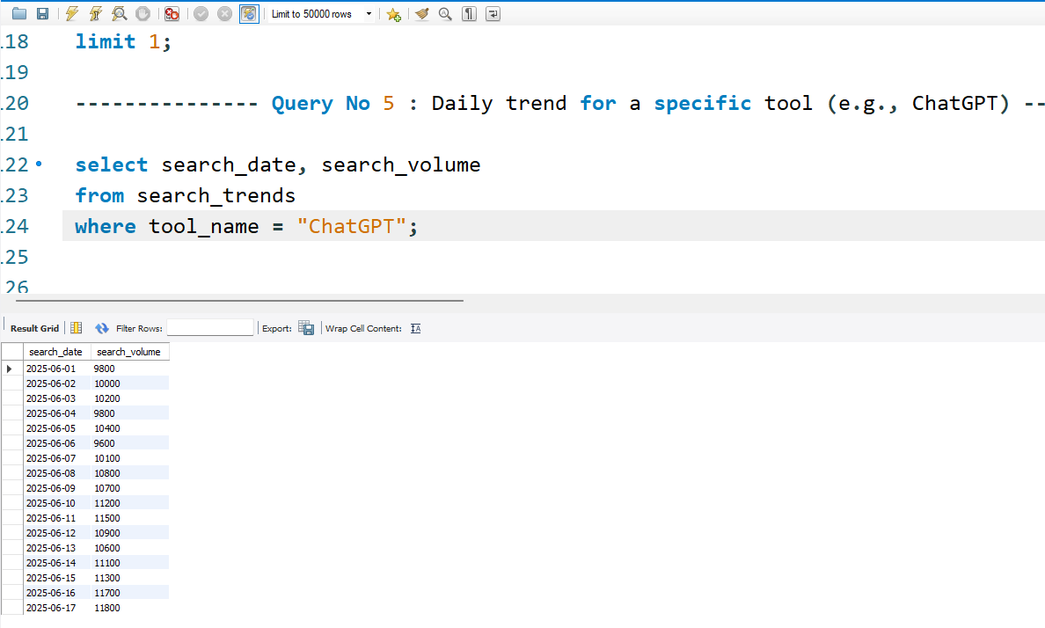

**Query 6 :**

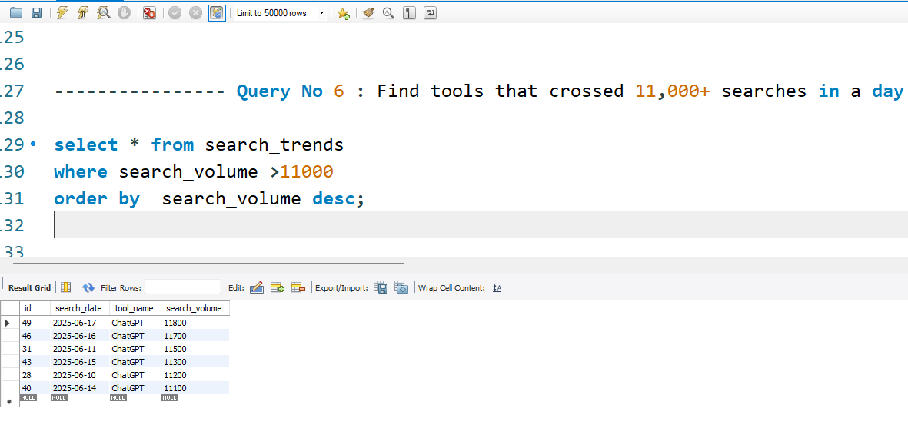

**Query 7 :**

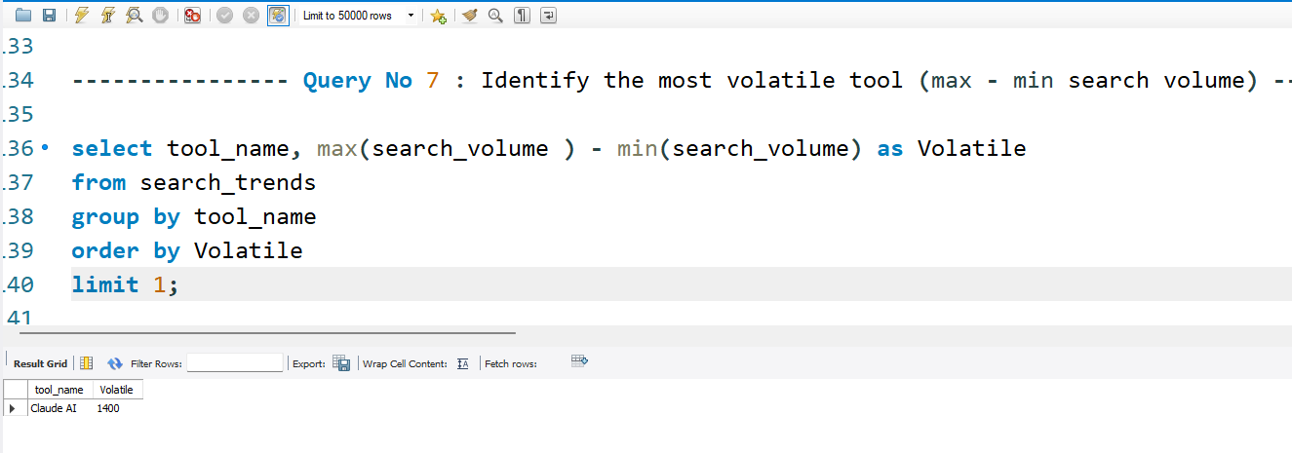

**Query 8 :**

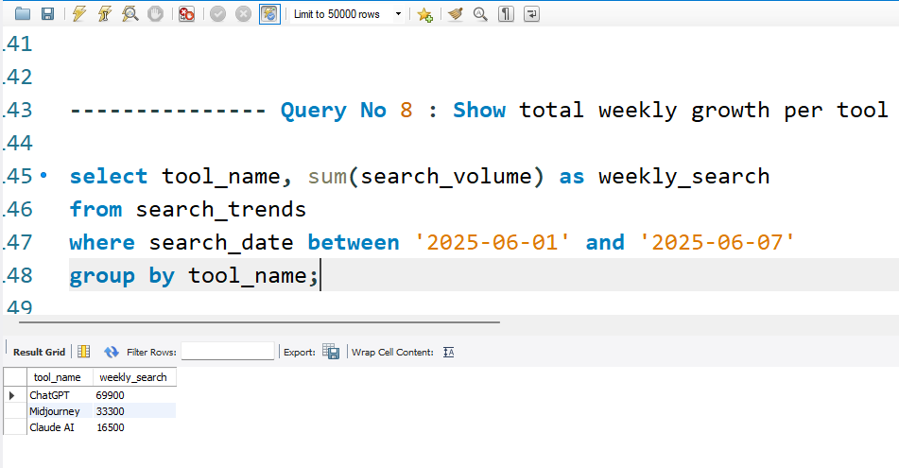

**Query 9 :**

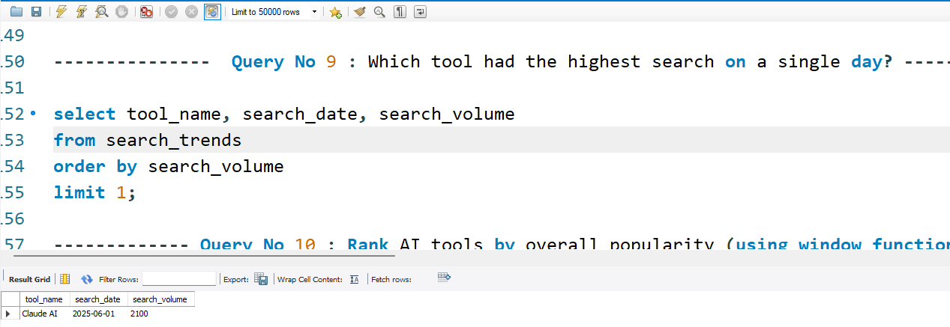

**Query 10 :**

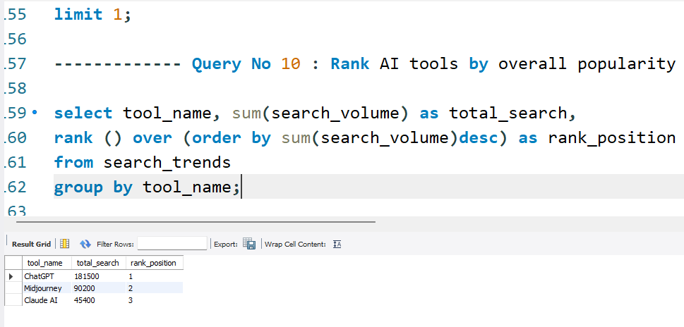

**Conclusion:**

This project demonstrates my ability to analyze real-world datasets using SQL and draw actionable insights without using complex joins. It reflects my problem-solving approach, business thinking, and readiness for entry-level data analyst roles.